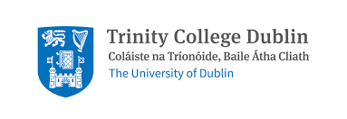
Participation Information Leaflet

Children with Rare Diseases: A survey of parent perspectives on their children’s speech, language, and communication needs

Are you the parent of a child with a rare disease? We would love to hear from you!
My name is Ciara Kelleher, and I am a fourth year Clinical Speech and Language Therapy student at Trinity College, Dublin.
As the parent of a child with a rare disease or condition you are being invited to take part in a survey about your perspective on the speech, language, and communication needs that your child experiences, and how they impact your child and their interactions with you and the world around them.
We want to explore the link, from your perspective, between rare diseases/conditions and speech, language, and communication capabilities, regardless of whether your child is accessing services.
The area of rare diseases, and in particular the areas of speech, language, and communication within it, are relatively under researched. A study such as this one is poignant, not only for people living with rare diseases and their families, but also for healthcare professionals and the provision of services in the area.
This is an anonymous survey and participation is voluntary. It will take approximately 15 minutes to complete and you may stop at any time.
The information obtained from this survey will be analysed as part of my Final Year Research Project under the supervision of Dr Yvonne Lynch.
By participating in the survey you are confirming that you are:
- the parent of a child under the age of 18 with a rare disease and;
- consenting to participate in the survey.

